MAIN PROJECT-2

Deploying Amazon RDS Multi-AZ and Read Replica, Simulate Failover in AWS

**Steps**:

1) Creating an EC2 instance:

* N.virginia region for performing a task.
* Launching an instance using default vpc and subnet, entering the script given below in user data section.
* **#!/bin/bash -ex**
* **yum install mysql -y**

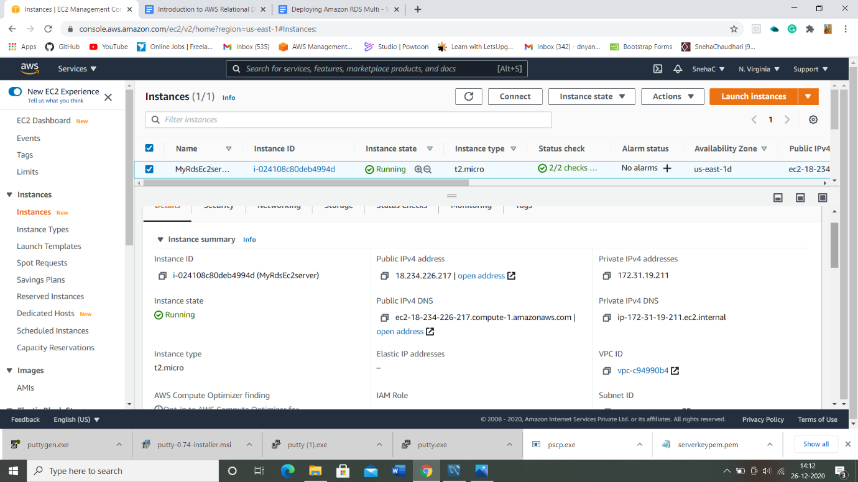

2) Security Group created for EC2:

* Security Group created with 2 inbound rules to add SSH.

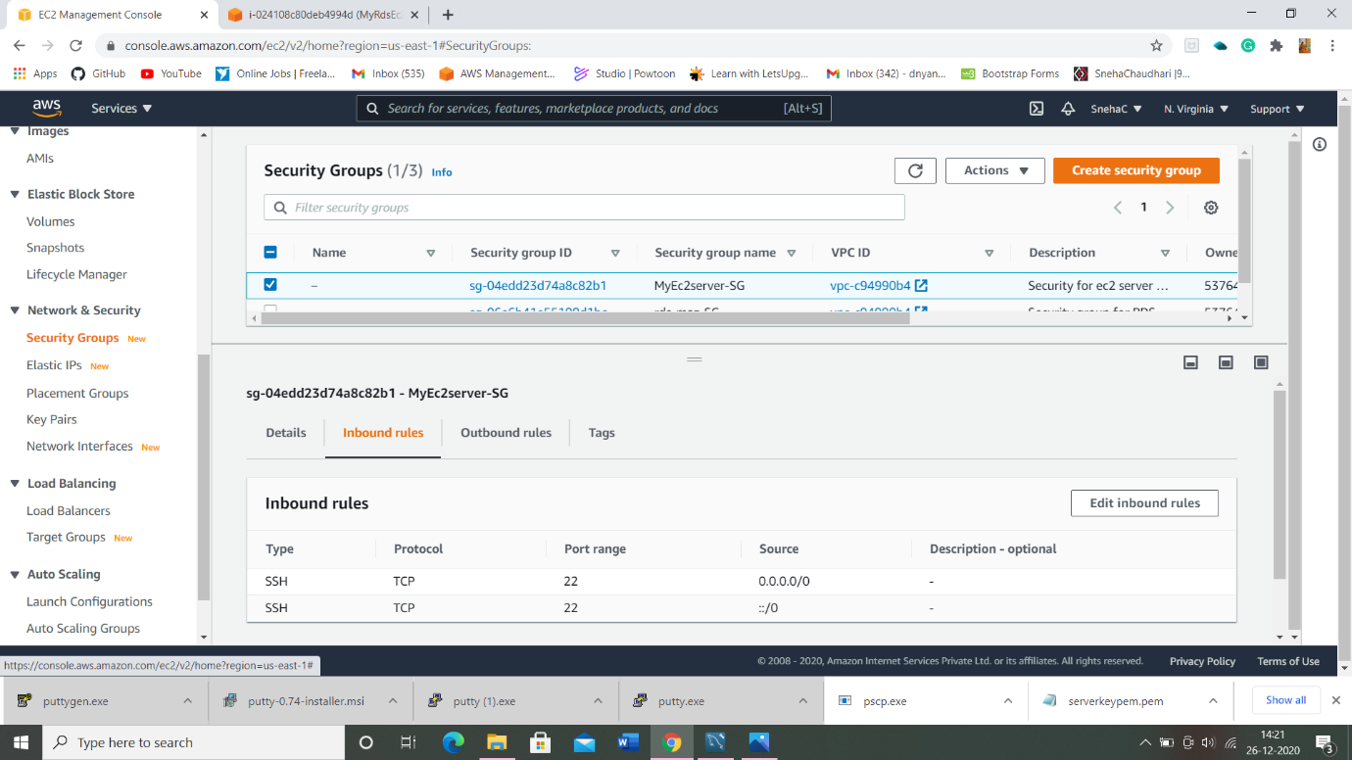

* Inbound rules of EC2 server instance:

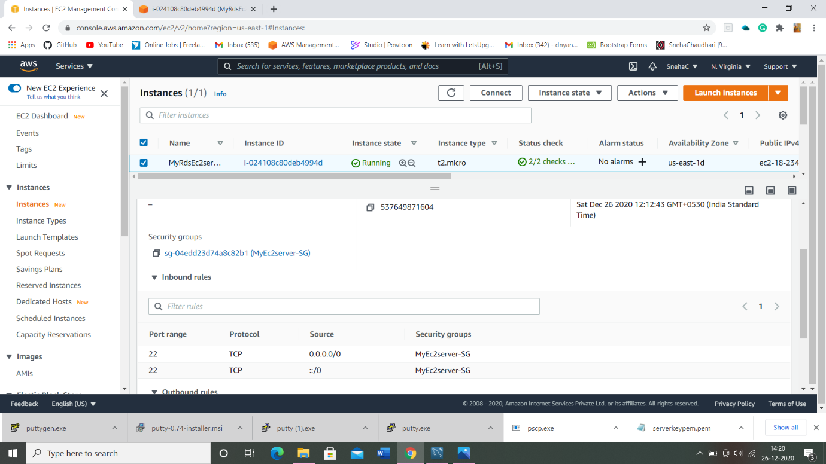

3) Security Group created for RDS instance:

* Security Group created with MYSQL/Aurora inbound rule (custom) to add SSH.

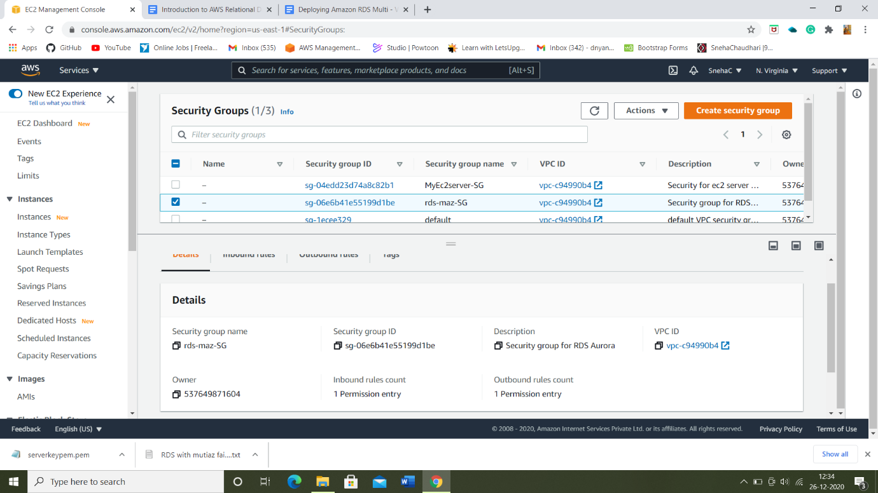

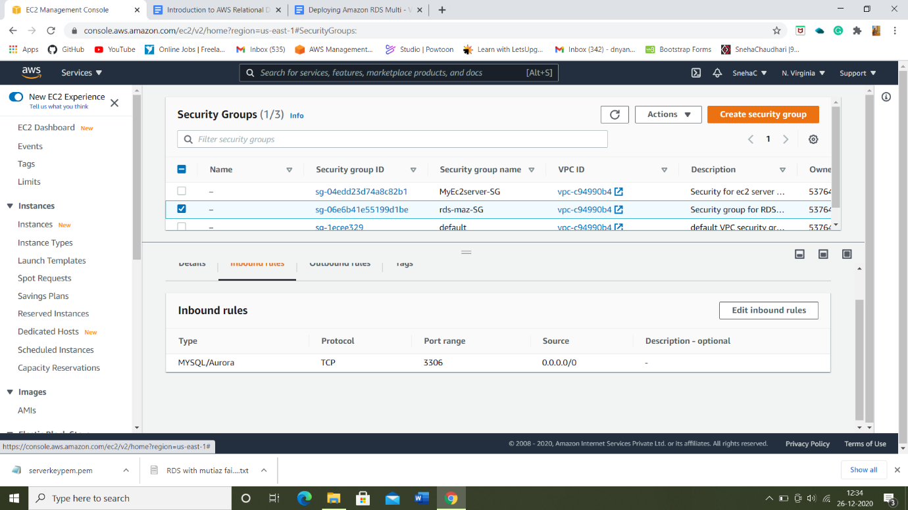

4) Creating an Amazon Aurora database with Multi-AZ enabled:

* Creating a database with all required changes such as version, Template: Dev/Test and Additional Configuration.

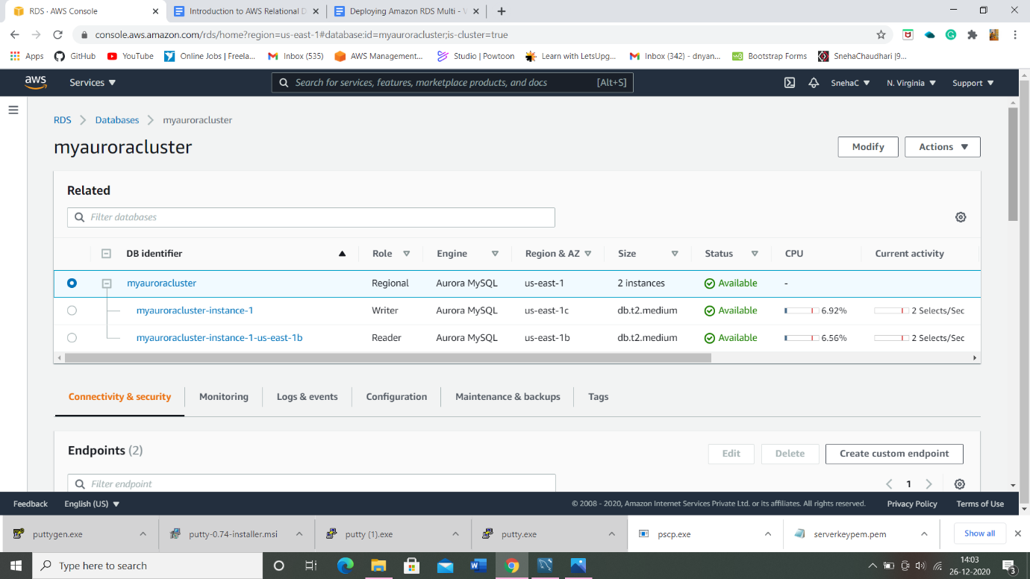

* Reader and Writer are created successfully.

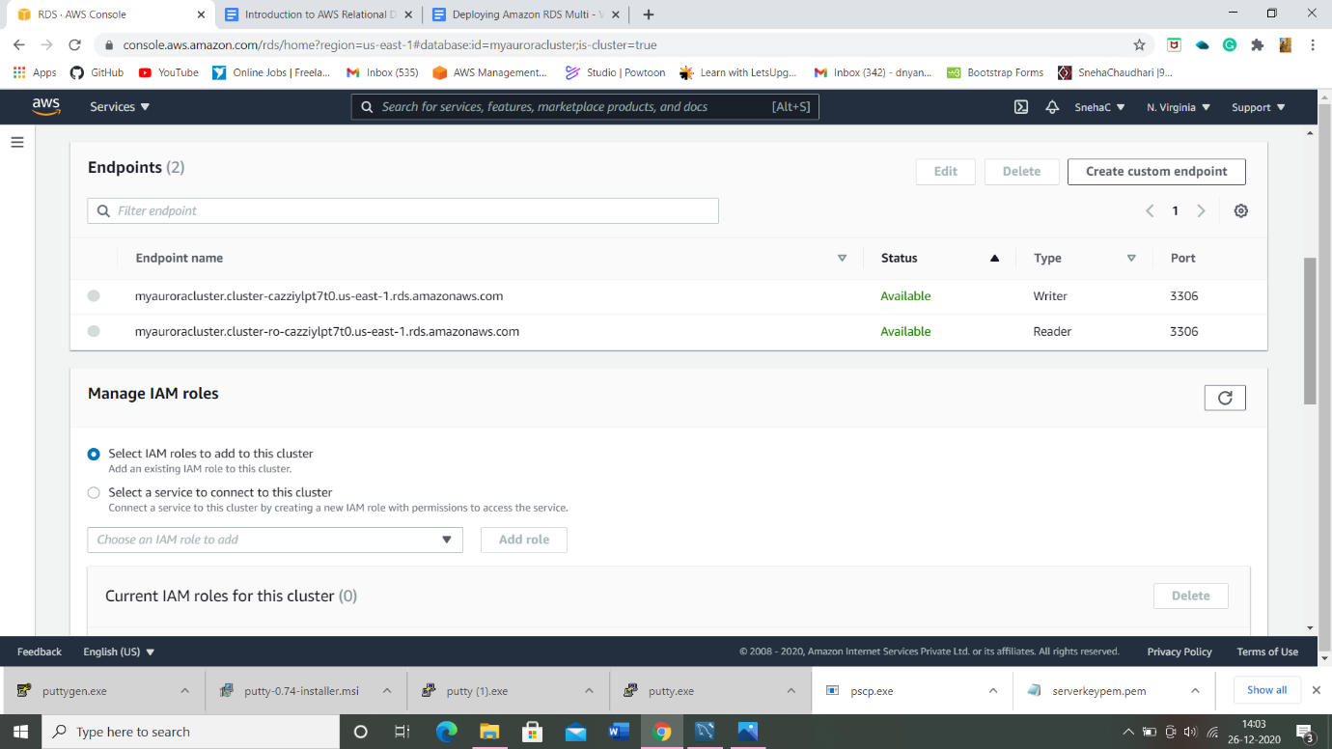

4) Connecting to the Aurora(MYSQL) database on RDS:

* Now we have successfully launched Aurora RDS with Multi-AZ enabled. To connect to the new Aurora database, we need the **endpoint.**

5) Connecting EC2 server to RDS:

* Now we need to connect the RDS with ec2 server in order to eventually connect with the Aurora database.

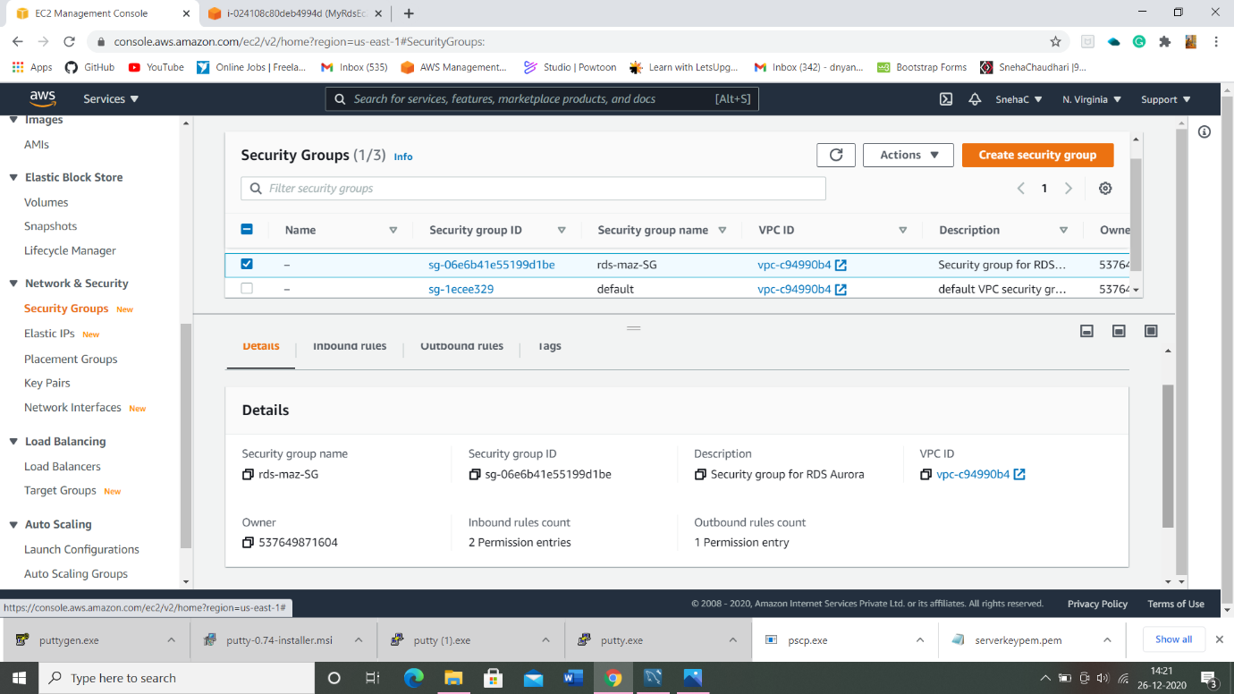

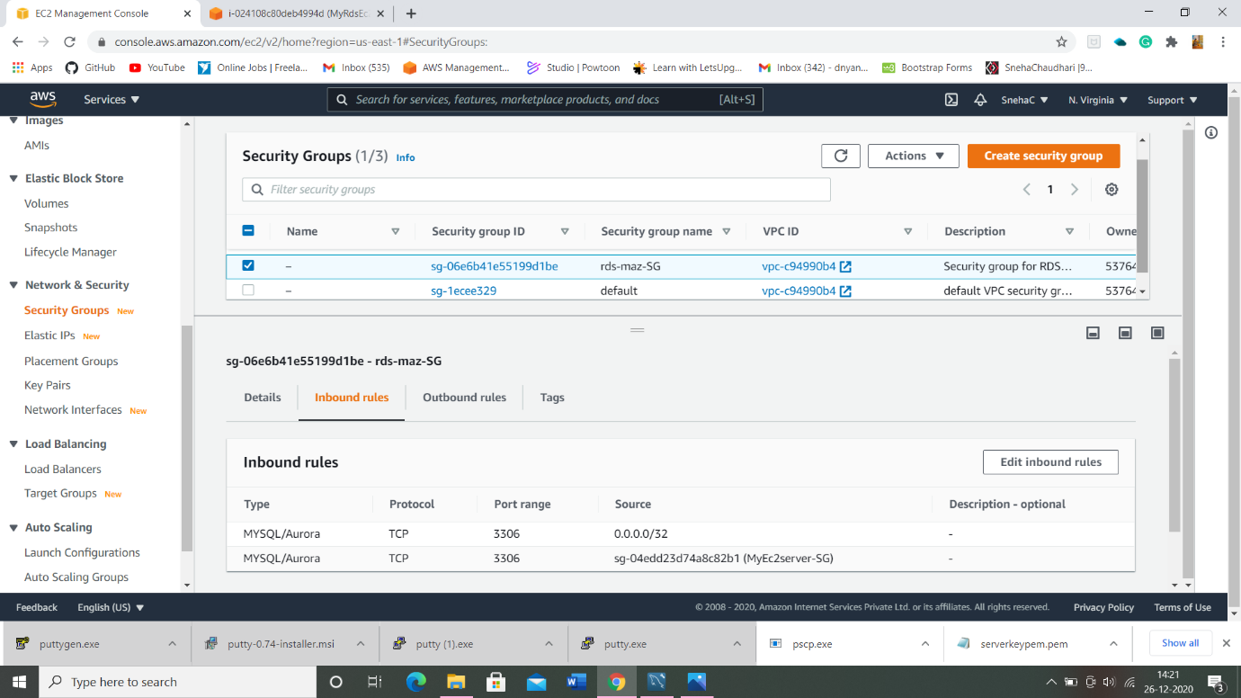

5) Executing database via SSH:

* Connect the EC2 instance and switch to root user.
* Log into RDS instance using:

Syntax: mysql -h <Hostname> -u <username> -p

-Hostname will be the path of Master(writer) and the username we created.

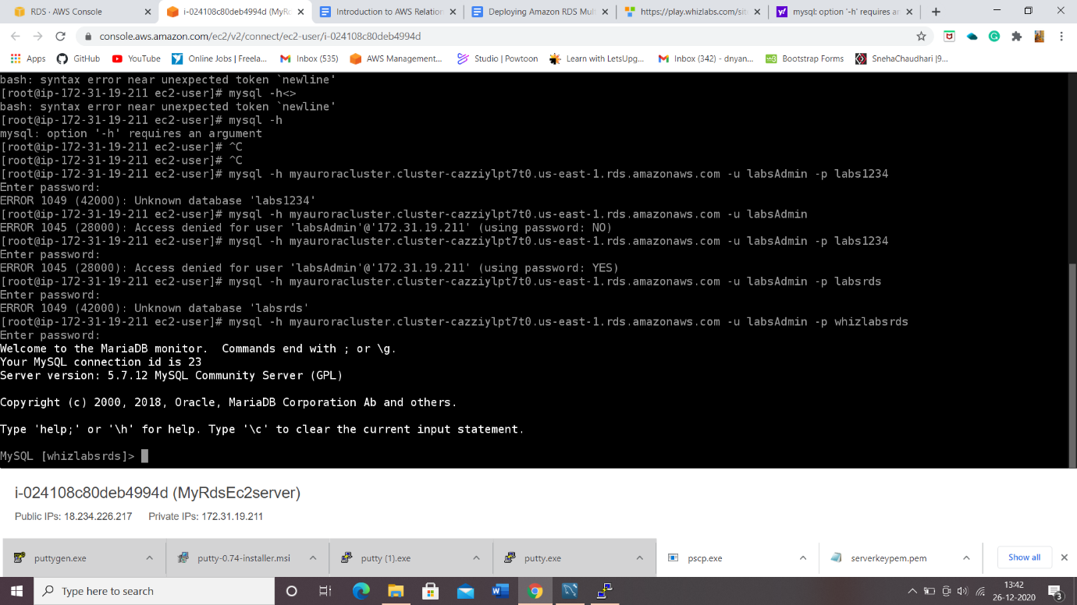

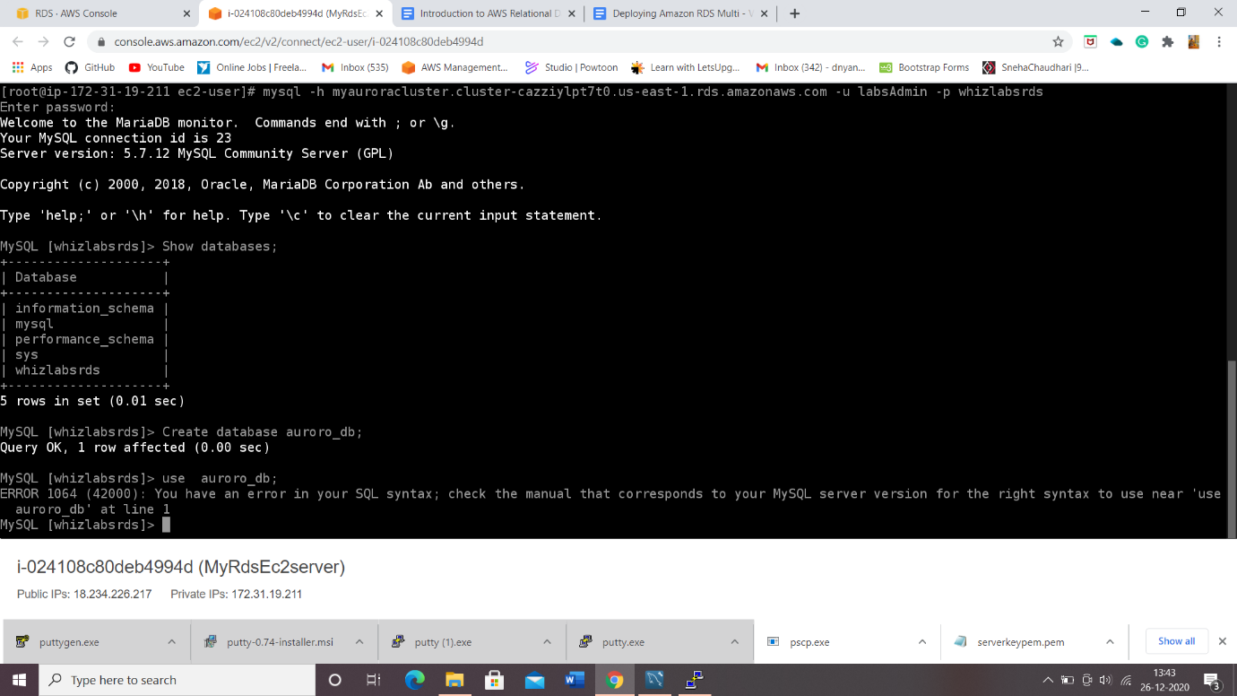

* Creating a new database named aurora_db and then creating a table named students and inserting values respectively.

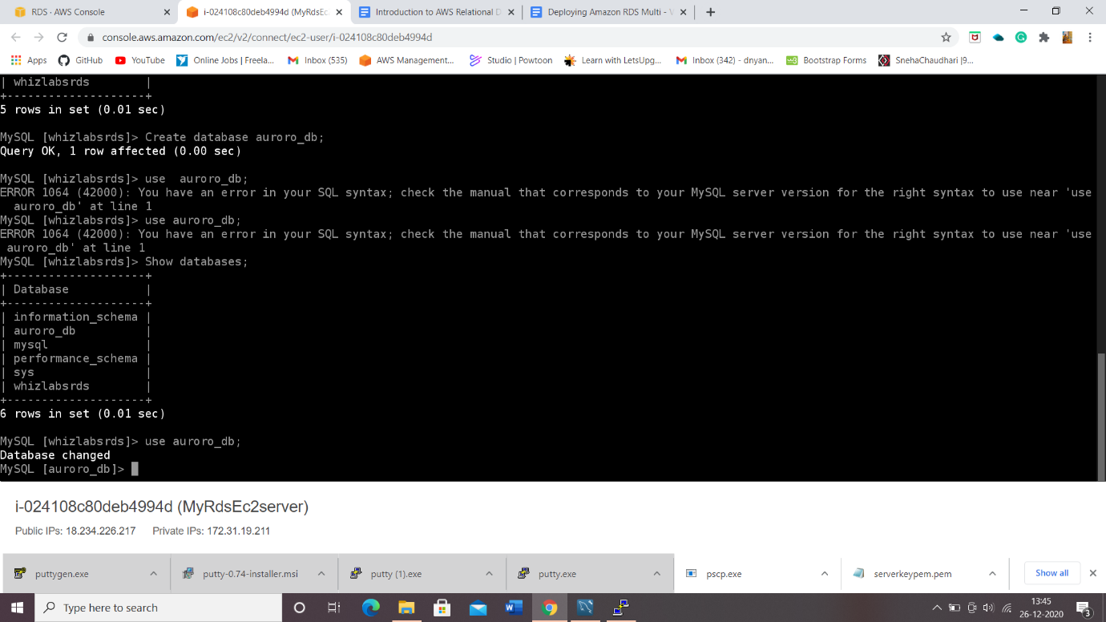

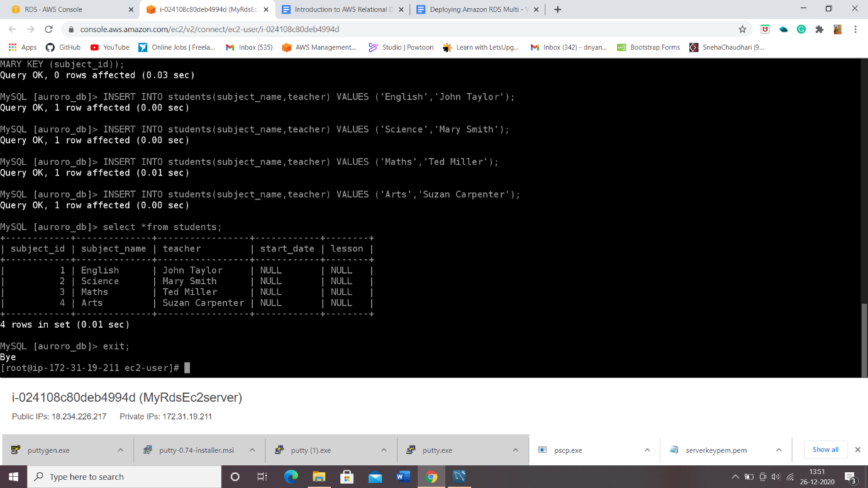

5) Forcing a Fail-over to Multi-AZ:

* To test if Multi-AZ is working, we will create a situation where master fails and the read replica has to become the new Master(Writer).

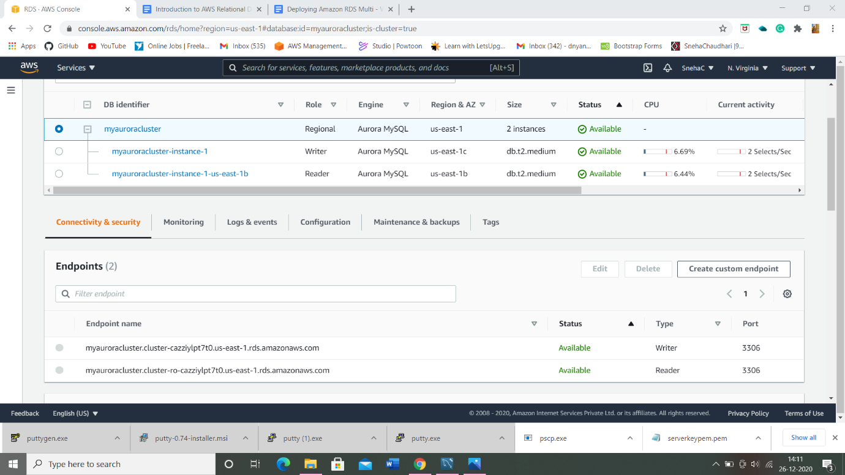

5) Testing the Failover condition:

* By following step 5).

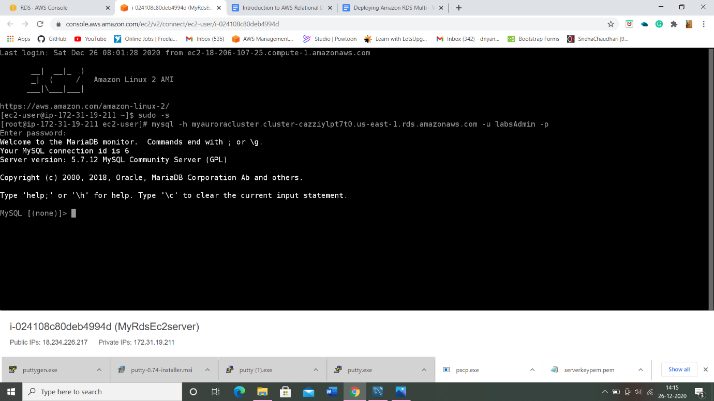

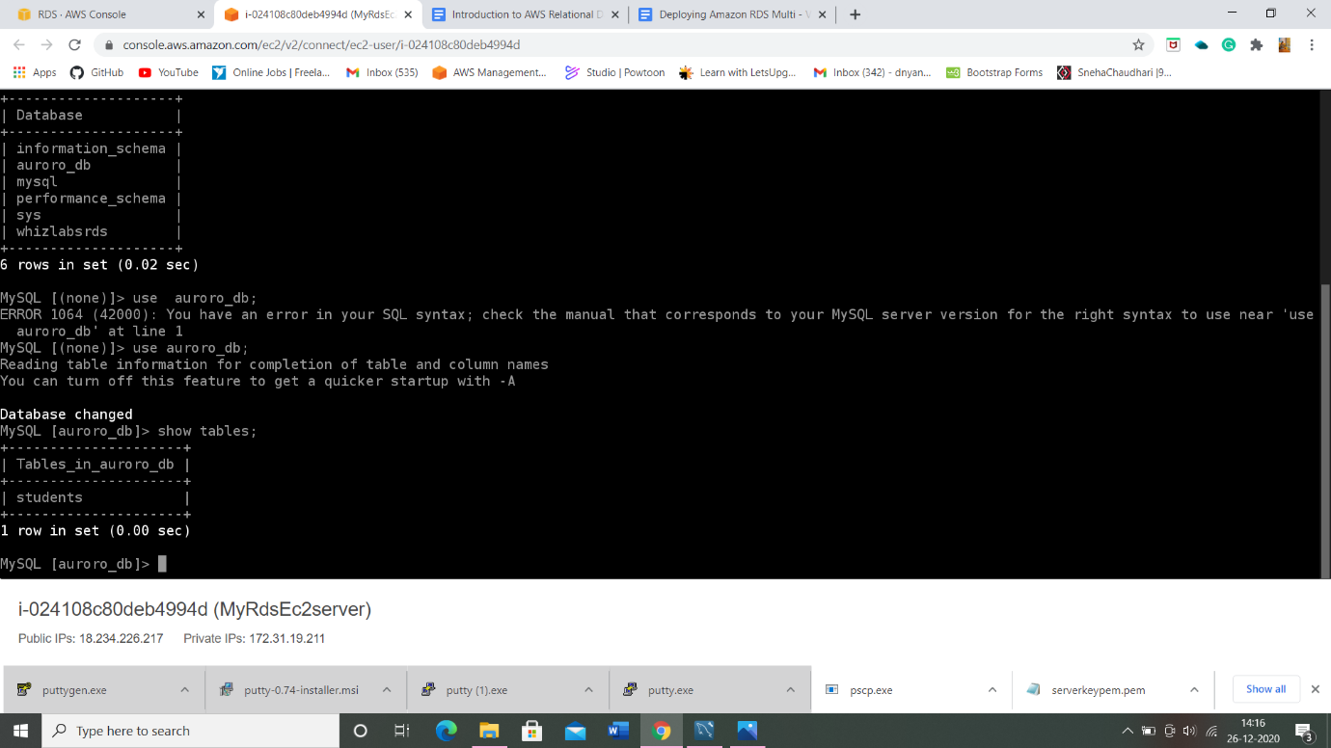

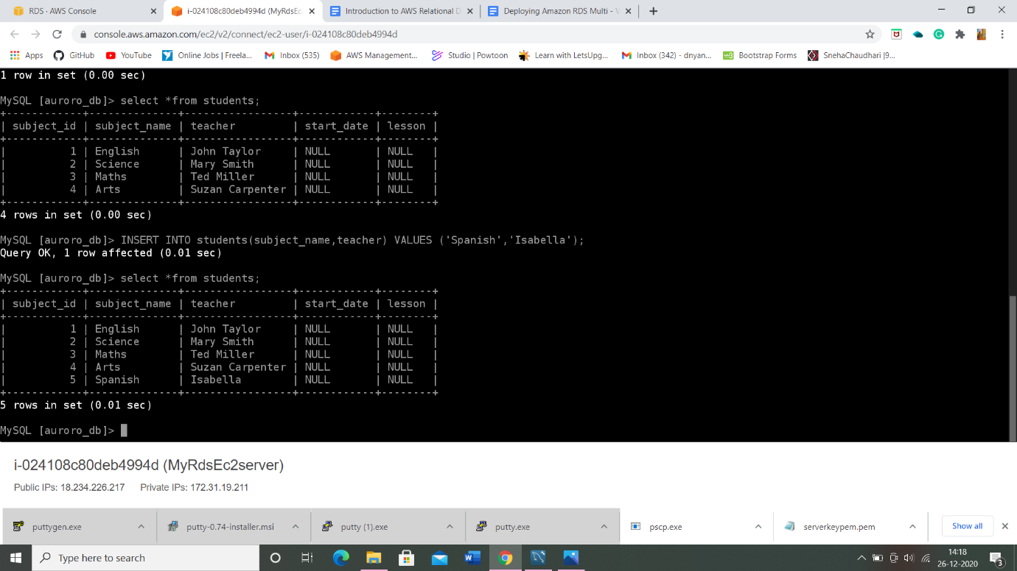

* The resources created on the original master db are present, implying that the Failover worked successfully.

**THE END**